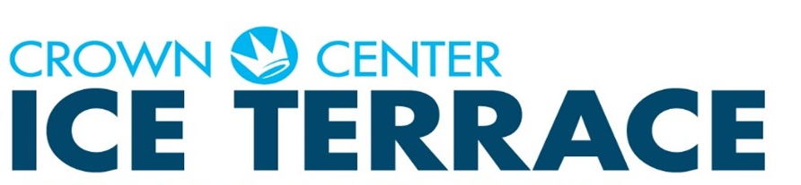

Skaters Code of Conduct and Assumption of Risk Agreement

Skaters and spectators understand and agree to all the following:

1. Maintain reasonable control of his/her speed and course at all times.
2. Read and abide by all posted signs and warnings and cooperate with the rink staff.
3. Maintain a proper lookout to avoid other skaters, objects or conditions on the surface of the rink.
4. Accept responsibility for knowing the range of his/her ability while on skates, and skate with-in the limits of that ability.
5. Not skate while under the influence of drugs, alcohol or other control-impairing substance.
6. Leave the surface when resurfacing maintenance is taking place.
7. Food and drinks are not allowed on the rink surface or the surface surrounding dasher or cap rail.
8. Refrain from acting in a manner that may cause or contribute to injury of themselves or any other person.
9. Assumption of risk agreement by engaging in skating, skaters are deemed to have knowledge of, and assume the inherent risks of skating including but are not limited to the following:

a. Injuries that result from collisions or contract with other skaters or individuals who are on the skating surface.

b. Injuries that result from falls.

c. Injuries that involve objects or artificial structures are properly within the intended path of travel of the skater.

1. Skaters will not throw or leave any foreign object on the rink surface.
2. Skaters will not instigate or become involved in any type of altercation with any other skater or with any spectator and will not engage in any abusive, abrasive, or disorderly conduct.

|  |  |  |
| --- | --- | --- |
|  | Crown Center Square, 25th & Grand Blvd., Kansas City MO-816.274.8411  Three hours free parking with validation from the Ice Terrace Pro Shop  www.crowncenter.com | Crwnlog4 |